Possible looks of Jesus Christ
 vs. 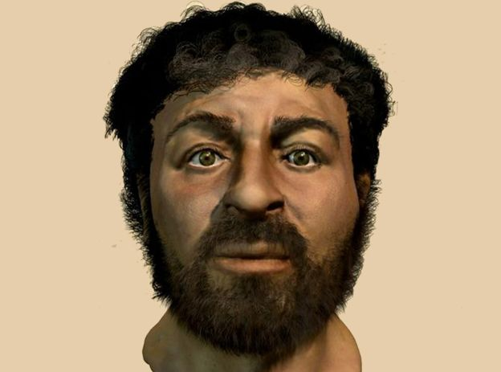
For a long time people has claimed that Jesus Christ was a bearded, white skinned man with a long light brown or blond hair and we also often see him in pictures with blue eyes. But the bible doesn’t describe Jesus appearance and the normal description isn’t exactly accurate to where he lived by that time. Jesus was a Palestian Jewish man living in Galilee in the first century, so there was no way he was going to be a light skin man with blond hair and blue eyes. In 2001, the retired medical artist Richard Neave led a team of Israeli and British forensic anthropologists and computer programmers in creating a new image of Jesus, based on an Israeli skull dating to the first century A.D., computer modelling and their knowledge of what Jewish people looked like at the time. Though no one claims it’s an exact reconstruction of what Jesus himself actually looked like, scholars consider that Jesus was around five feet tall, with darker skin, dark eyes, and shorter, curlier hair.
References
Pruitt, Sarah. (2019). History Stories. The Ongoing Mystery of Jesus’s Face. Recuperado en: 5 de diciembre de 2019: https://www.history.com/news/what-did-jesus-look-like

